搭建架构
VIP: 192.168.88.X # 你需要再选一个没被占用的 IP
主机A：192.168.88.71 Redis Master
主机B：192.168.88.72 Redis Replica

Redis 端口：6379
Redis 密码：Redis@123456
Redis 安装目录：/usr/local/redis
Redis 源码目录：/opt/redis-pkg/redis-stable
Redis 配置文件：/usr/local/redis/etc/redis-6379.conf

说明:
两台主机都使用 6379 端口，不冲突。
只有在同一台主机上运行多个 Redis 实例时，才需要使用不同端口。

基础准备
这里我实在找不到windows的正确下载方式，我选择的离线安装方式是找一台可以连接外网的linux主机下载
# 下载官方最新稳定版源码包
wget https://download.redis.io/redis-stable.tar.gz
# 下载校验文件，建议一起下载
wget https://download.redis.io/redis-stable.tar.gz.SHA256SUM
# 校验
sha256sum -c redis-stable.tar.gz.SHA256SUM
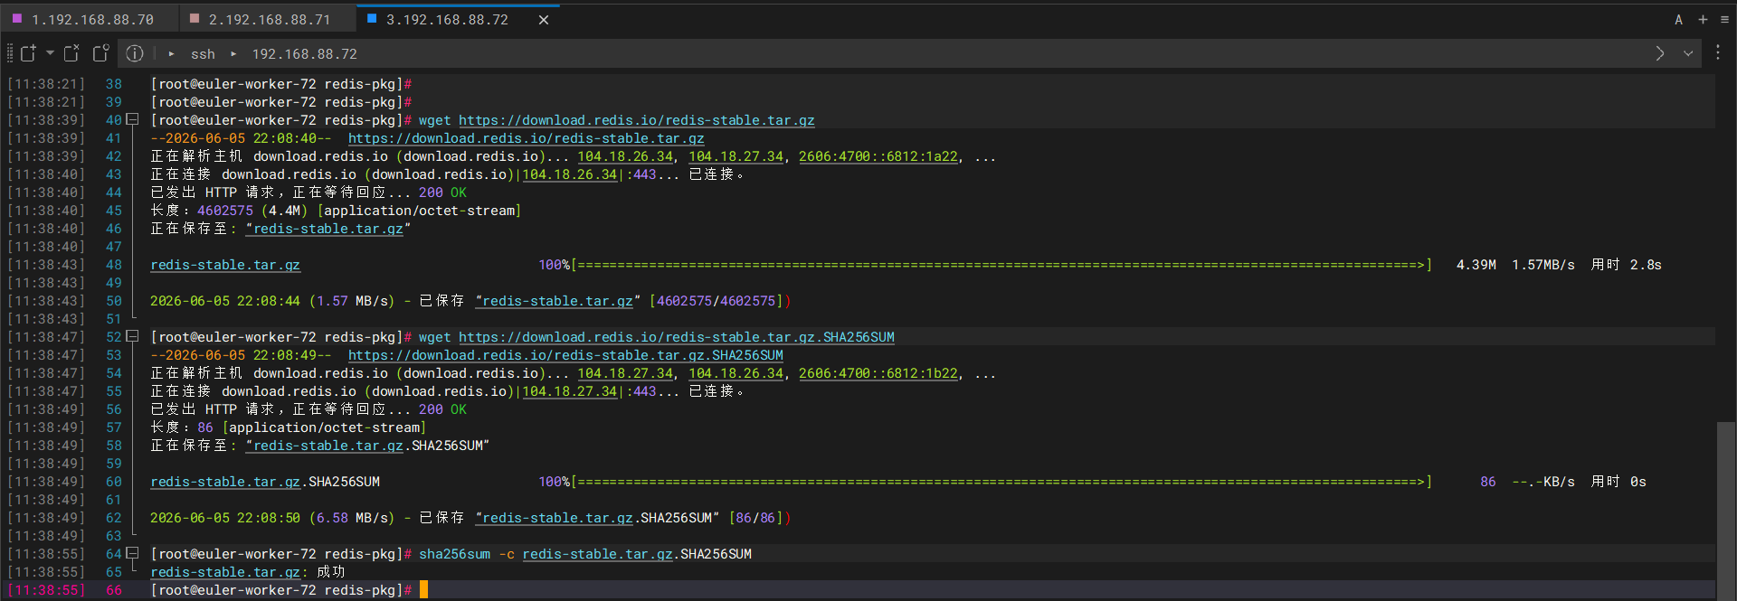
# 值得注意的是我的openeluer下的纯净版本,得提前安装编译工具
sudo dnf groupinstall "Development Tools" -y # 安装编译工具组
# 解压编译安装
tar -zxvf redis-stable.tar.gz
cd redis-stable
make -j$(nproc)
make install PREFIX=/usr/local/redis
# 确认安装是否成功
/usr/local/redis/bin/redis-server --version
/usr/local/redis/bin/redis-cli --version
# PATH环境变量
echo 'export PATH=$PATH:/usr/local/redis/bin' >> ~/.bashrc
source ~/.bashrc
# 确认
which redis-server
which redis-cli

# Redis 双机主备+主从复制(两台主机都需要执行)
mkdir -p /usr/local/redis/{etc,data,logs}
mkdir -p /var/run/redis
它们分别用途是:
/usr/local/redis/bin Redis 命令目录，make install 后已有
/usr/local/redis/etc Redis 配置文件目录
/usr/local/redis/data Redis 数据目录，存放 RDB/AOF
/usr/local/redis/logs Redis 日志目录
/var/run/redis Redis pid 文件目录

# 复制 Redis 配置模板然后分别修改主库和从库配置(两台主机都需要执行)
(这里不需要考虑端口问题,只有在同一台机器上跑多个 Redis 实例时，才需要改成不同端口)
# 其实这里覆盖也行,直接去对应的指定目录下创建新的空的redis-6379.conf也行
cp /**************源包解压位置/redis.conf /*******配置文件目录/redis-6379.conf
cp /opt/redis-pkg/redis-stable/redis.conf /usr/local/redis/etc/redis-6379.conf
# 检查配置完整性(没有报错表示完整)
ls -lh /usr/local/redis/etc/redis-6379.conf

主从复制
1.主库配置
vi /usr/local/redis/etc/redis-6379.conf
添加如下:
cat > /usr/local/redis/etc/redis-6379.conf <<'EOF'
bind 0.0.0.0
protected-mode yes
port 6379
daemonize no

pidfile /var/run/redis/redis-6379.pid
logfile /usr/local/redis/logs/redis-6379.log
dir /usr/local/redis/data

requirepass Redis@123456
masterauth Redis@123456

appendonly yes
appendfilename "appendonly.aof"
appenddirname "appendonlydir"

dbfilename dump.rdb

save 900 1
save 300 10
save 60 10000
EOF

2.从库配置
vi /usr/local/redis/etc/redis-6379.conf
添加如下:
cat > /usr/local/redis/etc/redis-6379.conf <<'EOF'
bind 0.0.0.0
protected-mode yes
port 6379
daemonize no

pidfile /var/run/redis/redis-6379.pid
logfile /usr/local/redis/logs/redis-6379.log
dir /usr/local/redis/data

requirepass Redis@123456
masterauth Redis@123456
# 这行是从库才有的,主库没有
replicaof 192.168.88.71 6379

appendonly yes
appendfilename "appendonly.aof"
appenddirname "appendonlydir"

dbfilename dump.rdb

save 900 1
save 300 10
save 60 10000
EOF

sys服务化
接下来做systemd服务(两台节点都创建,内容可以完全一样)
# 先创建服务文件
vi /etc/systemd/system/redis-6379.service
# 添加如下
[Unit]
Description=Redis 6379
After=network-online.target
Wants=network-online.target

[Service]
# 这里redis-6379.conf配置文件下的daemonize no必须是no
Type=simple
User=root
Group=root

ExecStartPre=/usr/bin/mkdir -p /usr/local/redis/data
ExecStartPre=/usr/bin/mkdir -p /usr/local/redis/logs
ExecStartPre=/usr/bin/mkdir -p /var/run/redis

ExecStart=/usr/local/redis/bin/redis-server /usr/local/redis/etc/redis-6379.conf
ExecStop=/usr/local/redis/bin/redis-cli --no-auth-warning -h 127.0.0.1 -p 6379 -a 'Redis@123456' shutdown

Restart=always
RestartSec=3
LimitNOFILE=65535

[Install]
WantedBy=multi-user.target

# 重新加载服务
systemctl daemon-reload
systemctl enable redis-6379.service
systemctl start redis-6379.service
systemctl status redis-6379.service

# 在两台主机上验证PONG
/usr/local/redis/bin/redis-cli --no-auth-warning -a 'Redis@123456' -h 192.168.88.71 -p 6379 info replication
出PONG就是正常

Keepalived VIP漂移

架构:
192.168.88.71 Redis Master Keepalived MASTER
192.168.88.72 Redis Replica Keepalived BACKUP
192.168.88.100 VIP

第一步:两台主机都安装Keepalived
# 安装
dnf install -y keepalived
# 检查安装
keepalived -v
# 确定网卡信息(需要做VIP漂移主机执行)
ip route get 192.168.88.1
这里能看到ens33,后面Keepalived配置里全部写ens33

第二步:创建监控检查脚本(两台安装redis主机都得创建)
# 创建脚本
vi /etc/keepalived/check_redis.sh
# 写入
cat > /etc/keepalived/check_redis.sh <<'EOF'
#!/bin/bash

REDIS_CLI="/usr/local/redis/bin/redis-cli"
REDIS_PASS="Redis@123456"
REDIS_HOST="127.0.0.1"
REDIS_PORT="6379"

${REDIS_CLI} --no-auth-warning -h ${REDIS_HOST} -p ${REDIS_PORT} -a "${REDIS_PASS}" ping | /usr/bin/grep -q PONG

if [ $? -eq 0 ]; then
exit 0
else
exit 1
fi
EOF

# 给权限
chmod +x /etc/keepalived/check_redis.sh
# 测试,返回0就是正常
/etc/keepalived/check_redis.sh
echo $?

第三步:创建对应的keepalived.conf
1.先在主节点上执行
vi /etc/keepalived/keepalived.conf
# 写入
global_defs {
router_id redis_71
}

vrrp_script check_redis {
script "/etc/keepalived/check_redis.sh"
interval 2
timeout 2
fall 2
rise 1
weight -30
}

vrrp_instance VI_REDIS {
state MASTER
interface ens33
virtual_router_id 100
priority 100
advert_int 1

authentication {
auth_type PASS
auth_pass RedisVIP123
}

virtual_ipaddress {
192.168.88.100/24
}

track_script {
check_redis
}
}
2.在从节点上写入
vi /etc/keepalived/keepalived.conf
# 写入
global_defs {
router_id redis_72
}

vrrp_script check_redis {
script "/etc/keepalived/check_redis.sh"
interval 2
timeout 2
fall 2
rise 1
weight -30
}

vrrp_instance VI_REDIS {
state BACKUP
interface ens33
virtual_router_id 100
priority 90
advert_int 1

authentication {
auth_type PASS
auth_pass RedisVIP123
}

virtual_ipaddress {
192.168.88.100/24
}

track_script {
check_redis
}
}

第四步:配置文件添加完成后开始启动keepalived服务(两台主机全部执行)
# 设置开机启动
systemctl enable keepalived
systemctl restart keepalived
systemctl status keepalived

开始测试
# 验证VIP
ip addr show ens33 | grep 192.168.88.100
先在主节点上执行(VIP存在的位置)，会看到VIP节点的输出信息
在从节点上执行，是没有VIP的输出信息的
先在直接停止主节点的redis服务(模拟redis挂掉的情况)
# 停止
systemctl stop redis-6379.service
# 查看状态
systemctl status redis-6379.service
停止redis服务后，发现没有VIP的输出
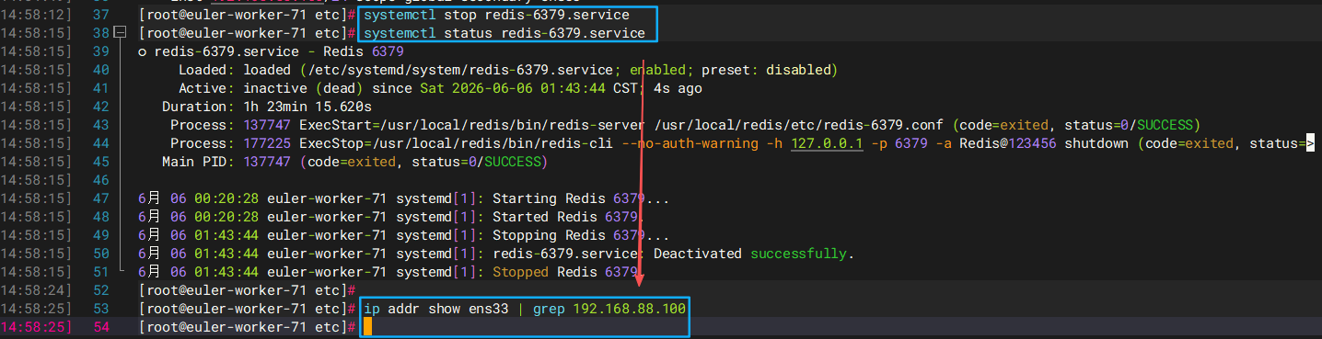
现在去从节点查看VIP服务，会发现VIP会自动漂移至从节点
我们在重新启动主节点的redis服务(模拟redis挂掉之后修复的情况)
# 启动
systemctl start redis-6379.service
# 查看状态
systemctl status redis-6379.service
# 查看VIP
ip addr show ens33 | grep 192.168.88.100
重启主节点redis服务后,VIP自动漂移至主节点
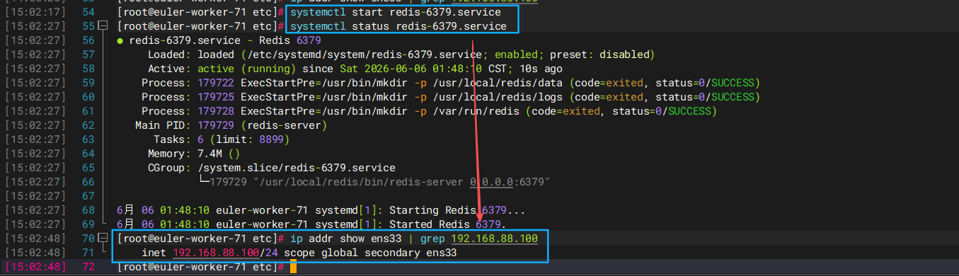

[选用]连接远程工具
远程连接工具连接就不再访问它的真实IP了,而是连接VIP
Host：192.168.88.100
Port：6379
Password：Redis@123456
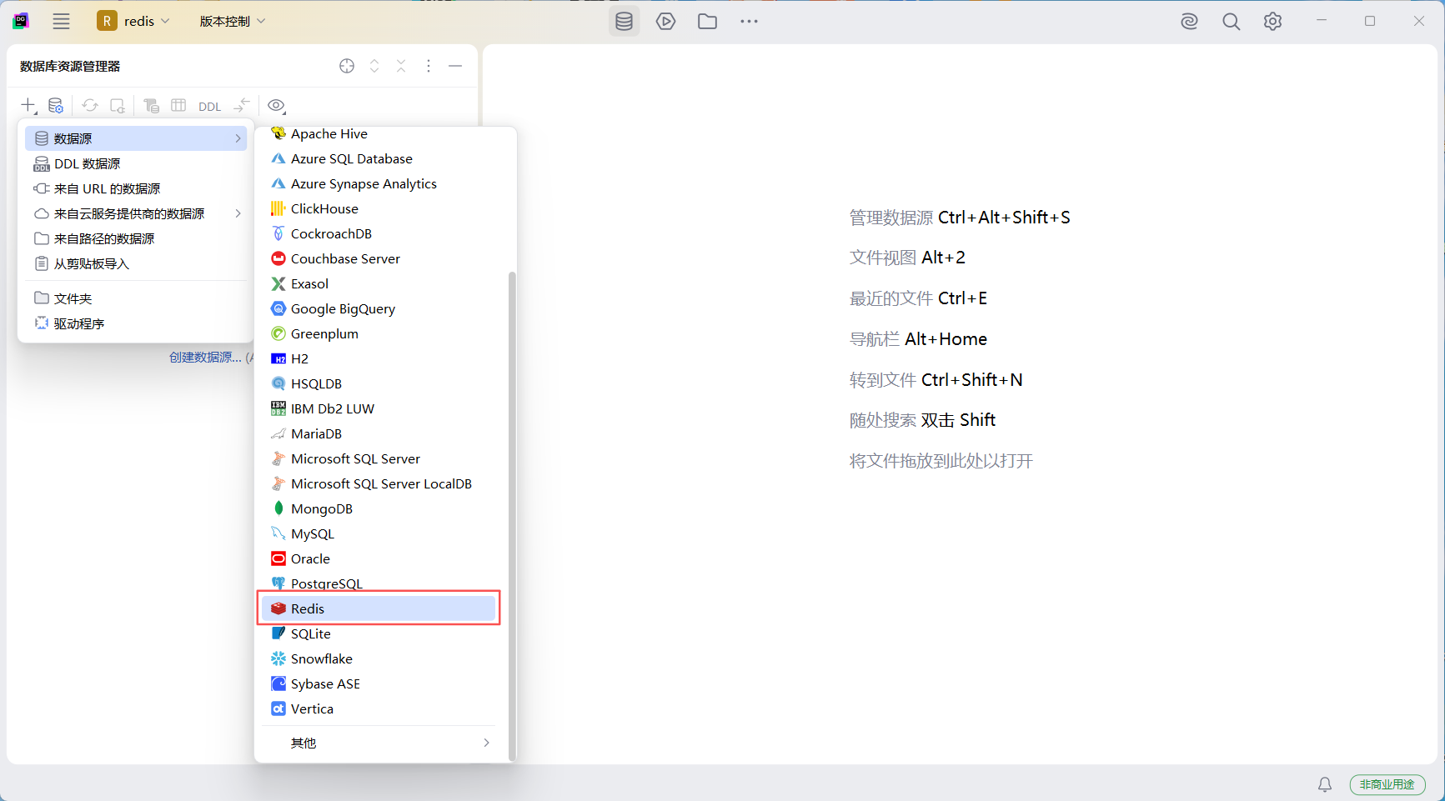
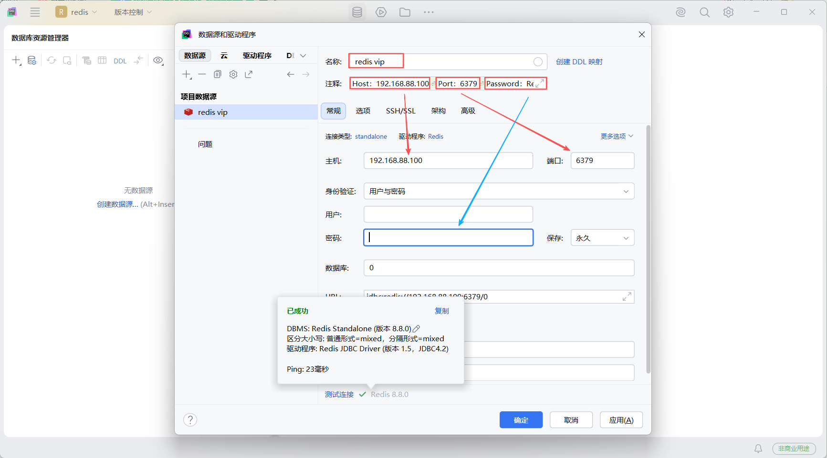
测试连接通过后，应用，确定。Redis 双机主备+主从复制+Keepalived VIP 漂移搭建完成!!!

